Multifunctional platform and mobile application for plant disease detection
Alexander Uzhinskiy ª, Gennady Ososkov, Pavel Goncharov, Andrey Nechaevskiy
Joint Institute for Nuclear Research, 6 Joliot-Curie, Dubna, Moscow region, 141980, Russia
E-mail: ª auzhinskiy@jinr.ru
Crop losses are the major threat to the wellbeing of rural families, to the economy and governments, and to food security worldwide. We present a multifunctional platform for plant disease detection (PDDP). PDDP consists of a set of interconnected services and tools developed, deployed, and hosted with the help of the JINR cloud infrastructure. PDDP was designed using modern organization and deep learning technologies to provide a new level of service to the farmer’s community. The mobile application allowing users to send photos and text descriptions of sick plants and get the cause of the illness and treatment is part of PDDP. We collected a special database of the grape, wheat and corn leaves consisting of fifteen sets of images. We have tried different neural network architecture on this data and select the best one. The architecture and basic principles of the platform and networks are described and compared with other well-known solutions.
Keywords: siamese networks, convolutional neural networks, deep learning, plant disease detection

Alexander Uzhinskiy , Gennady Ososkov, Pavel Goncharov, Andrey Nechaevskiy

Copyright © 2019 for this paper by its authors. Use permitted under Creative Commons License Attribution 4.0 International (CC BY 4.0).
- Introduction
Plant diseases are a serious threat to the economy and food security worldwide. According to some well-known researches, crop losses by diseases are between 10 and 30% [1]. An increasing number of smartphones and advances in deep learning field can help with this problem. We started this project in 2018. By that time, there were many kinds of researches in which deep learning was used to identify plant diseases. Some of them report about a great detection level, more than 96%. Generally, researches use transfer learning approaches and images from the PlantVillage [2] (open at that time database with 54,306 images of 14 crop species) or self-collected databases. However, there was a lack of a real application or sites where one could upload an image and get a prediction. The only mobile application we found that really could recognize plant diseases was Plantix [3]. Back to 2018, Plantix accuracy of detection on our test subset of 70 images was over 15%.
We tried to reproduce some of the researches and get good results with detection of the grape diseases on PlantVillage images – over 99% accuracy, but on the test subset from the internet accuracy was less than 50% [4]. The problem was in the synthetic nature of the PlantVillage images – same light, background and leaves orientation. We could not find any alternatives to PlantVillage so we have to create our own database of disease leaves. We understand that to facilitate the detection and preventing of the diseases of agricultural plants we should not only develop a good model but also create all necessary environments to work with it. That how we decided to develop a multifunctional platform that should use modern organization and deep learning technologies to provide a new level of service to a farmer’s community.
- Architecture and abilities
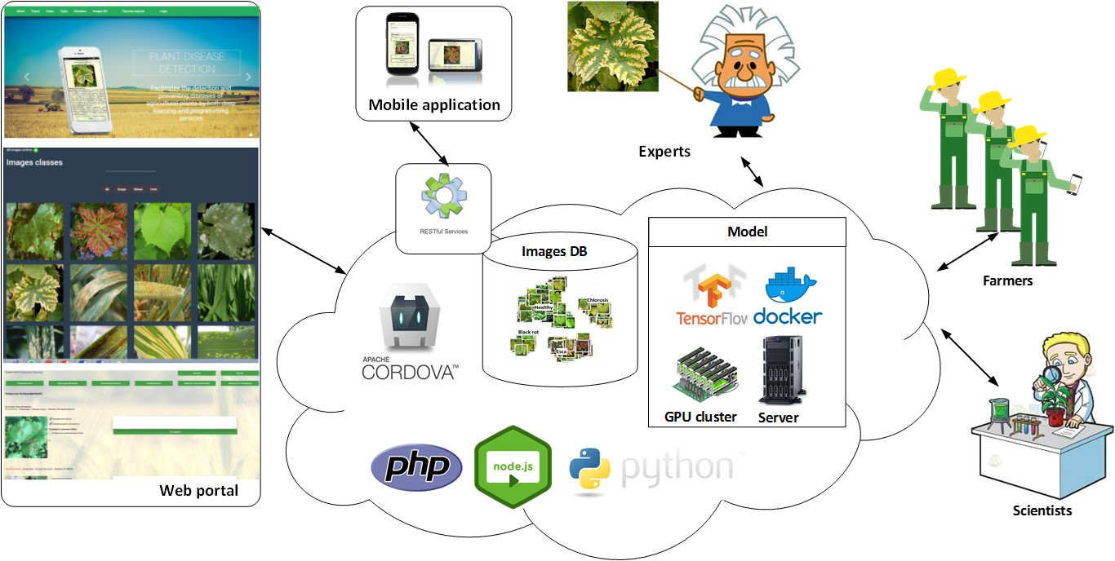
Figure 1. Architecture of the platform
PDDP consists of a set of interconnected services and tools developed, deployed and hosted at Joint institute for nuclear research cloud infrastructure [5]. This provides the necessary scalability of the solution and if some part of the platform will require more resources, they can be easily allocated.
Users communicate with the PDDP through the web-portal (pdd.jinr.ru), the mobile application or web-services. Web-portal has the public and the private part to provide to users, to experts, and supervisors all the necessary interfaces for work and communication. The image database is open and free for download. The TensorFlow model realized as a Tensorflow serving in Docker container, so it can work at the virtual server or a GPU cluster.
PDDP users could: send photos and text descriptions of sick plants through web-interface or mobile application and get the cause of the illness; browse through disease description and galleries of ill plants; verify that requested disease was recognized right and treatment helps.
PDDP experts could: browse user requests and verify the correctness of the recognition; request addition of their image or image from the user requests to the DB; request changes of the description of the disease; request retraining of the model with new images.
PDDP supervisors could: add new images to the database; initiate retraining of the model; get different statistical metrics about portal users.
Researchers could: download all or only part of the base, work with image database through web-interface or API.
- Mobile application
PDDP users can run recognition tasks from the private or public part of the web-portal, but we believe that the most convenient way is the mobile application. We developed the mobile application using the Apache Cordova, so we could build it for Android, iOS, and Windows. Currently, we deployed only the Android version that could be found at Google Play under the “PDDApp” name.
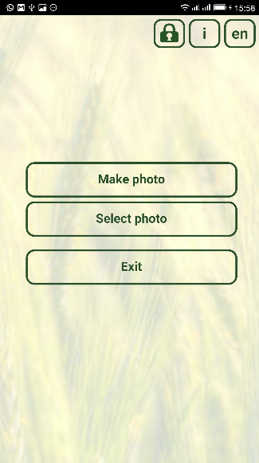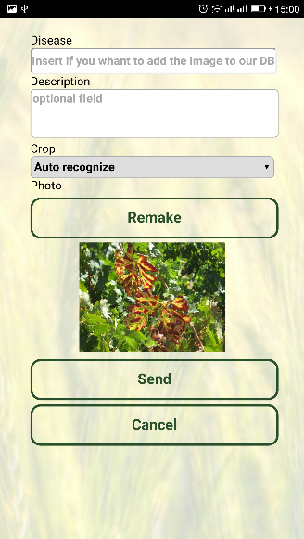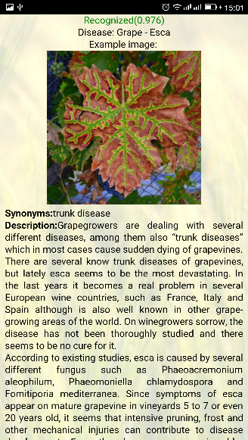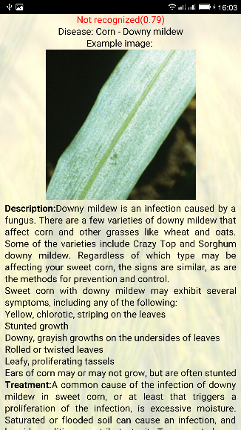
Figure 2. Examples of the PDDApp interfaces
A user has the opportunity to take a photo of the diseased plant and get a prediction for the disease and treatment suggestions. It is possible to download images if a user could not take a photo. The application requires access to the Internet to work. We have tried to run the model on the mobile device and manage to decrease the size of the model ten times without serious accuracy lost. We are going to realize offline mode for the application when crops and disease description data settles down.
- Model and image database
The most popular way to deal with image classification problems in a vast majority of domains is to use a deep neural network trained on a big dataset with further fine-tuning the chosen deep classifier on your dataset. We made our comparative study of transfer learning models that are available in open access and found out that ResNet50 architecture reached 99.4% classification accuracy on a test subset of the PlantVillage data but was stuck on our self-collected dataset with unsatisfactory 48%. We have investigated the problem and found that it refers the type of the used images. PlantVillage photos were collected and processed under special controlled conditions, so they are rather synthetic and differ from real-life images. It gave us the idea of creating our database. At the very beginning, our database has only 5 classes of grape leaves (healthy, esca, chlorosis, powdery mildew and black rot) – 313 images total. The only way to train a deep neural network on a small dataset is one-shot learning, in particular, Siamese networks [6]. Siamese network consists of twin networks joined by the similarity layer with energy function at the top. Weights of twins are tied (the same), thus, the result is invariant and also guarantees that very similar images cannot be in very different locations in features space. The similarity layer determines some distance metric between so-called embeddings, i.e. high-level features representations of input pair of images. Training on pairs is more beneficial since it produces quadratically more possible pairs of images to train the model on, making it hard to overfit. From the trained one-shot model, the encoder network represented as «shoulder» of that model or so-called twin is extracted for further use as a feature extractor. The role of the classifier takes the k-nearest neighbors algorithm which operates on the feature vectors - outputs of the trained twin. For the distance metric the cosine similarity was applied. Parameter K was set to 1 to be equivalent to the one-shot learning task. Classification accuracy of the model was measured on a test subset of grapes images and reached 95% using all five classes [4].
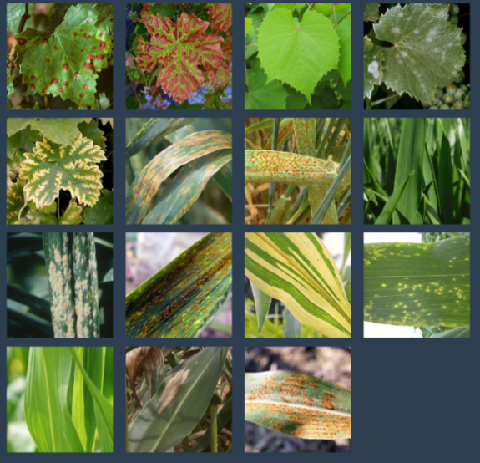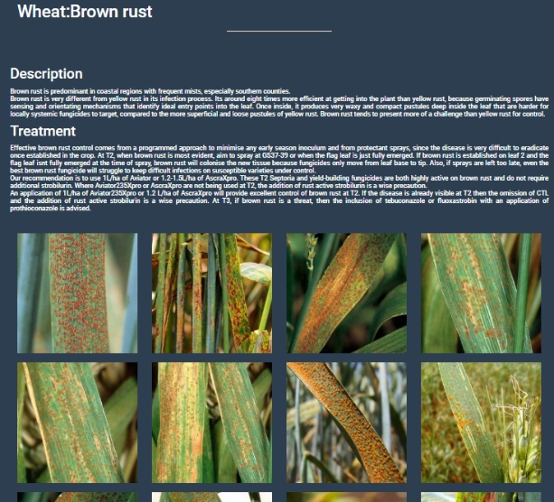
Figure 3. PDDP image database
We have expanded the PDDP database since the previous results were published. We have added two other crops – wheat and corn. Each of the added crops is represented by 5 sets of images: corn (diseases: downy mildew, eyespot, northern leaf blight, southern rust and healthy) and wheat (diseases: black chaff, brown rust, powdery mildew, yellow rust and healthy). The final version of the dataset includes 15 classes with 611 leaf photos in total. After training on all 15 classes even for 150 epochs, the best version of the model obtained 86% test classification accuracy. Probably, such a decrease in accuracy value may be caused by using KNN as a classifier. It is a wellknown fact that KNN suffers from hubs when working with high-dimensional data. A hub is a node which tends to have much more in-going edges than the other nodes. To deal with hubs one can reweight all distances using special scaling parameters, or simply replace KNN with another classifier.
Figure 4. The best NNA architecture: one of two Seamese twins and single-layer perceptron
To improve the test classification accuracy we made a special comparative study of different types of estimators including logistic regression, support vector machines with cosine similarity as a kernel, decision tree, random forest, gradient boosting and a simple single-layer perceptron with one input and one output layer ending with softmax activation. The single-layer perceptron being trained for 100 epochs with Adam optimizer allows us to obtain the classification accuracy equals to 95.71% on the test subset of images. The best architecture we created is presented in figure 4.
- Alternatives
By September 2019, the only known alternative to our solution was Plantix. Plantix models improve a lot for the last year and detection accuracy on the test subset of 70 images now is over 50%. Fortunately, there is no information about their models and their image database is closed.
For the last few years more and more popular become AutoML solutions helping non-machine learning experts solve tasks of image recognition and classification. The AutoML services allow users to upload their datasets, automatically selects and trains machine-learning models and provides interfaces to use models. We decided to compare our models with few commercial AutoML platforms: Google Cloud Vision [7], Microsoft Custom Vision [8], and IBM Watson Visual Recognition [9]. We created the test subset of images consisting of 30 images that were used for model training, 30 images that were not used for training and 20 images out of our crop diseases domain. The results are presented in Table 1. As one can see, our new model has a detection level similar to the models created by commercial platforms.

Table 1. Comparison of detection accuracy as numbers of correctly recognized images for each group of PDDP and AutoML models (except of the last row where the numbers of misclassified images are shown).
 | Old model | New model | Google  Cloud Vision | Microsoft  Custom Vision | IBM Watson  Visual Recognition
Known (30) | 27 | 29 | 28 | 29 | 29
Unknown (30) | 20 | 24 | 22 | 25 | 25
Not in domain (20) | 0 | 5 | 1 | 7 | 2
- Acknowledgement
The reported study was funded by RFBR according to the research project № 18-07-00829.

- Conclusion
We developed PDDP to facilitate the detection and preventing diseases of agricultural plants. Our web-portal and mobile application are ready to use. We have the database of 3 crops and 15 classes, 613 images total that can be downloaded from pdd.jinr.ru. We developed the special siamese transfer learning method which leads to significant accuracy gain. We compared our solution with some well-known AutoML products and shown that our model detects diseases well.
We are going to expand our images DB and improve the mobile App and the web-portal. We will explore other types of siamese loss functions (triplet loss) and optimization of the existing deep neural network architecture. We are working on the model for classification by text-description. Currently, we support Russian and English languages. The Arabic language is also in our plans.
References
[1] Serge Savary, Andrea Ficke, Jean-Noël Aubertot, Clayton Hollier, Crop losses due to diseases and their implications for global food production losses and food security // Springer Food Security, Vol 4, pp 519–537, 2012
[2] PlantVillage project home page [Electronic resource]: https://plantvillage.psu.edu/. (Accessed 1.10.2019)
[3] Plantix project home page [Electronic resource]: https://plantix.net. (Accessed 1.10.2019)
[4] Goncharov, P., Ososkov, G., Nechaevskiy, A., Uzhinskiy, A., Nestsiarenia, I. Disease Detection on the Plant Leaves by Deep Learning. International Conference on Neuroinformatics. Springer, Cham, p 151-159, 2018
[5] Korenkov V. , Balashov N., Kutovskiy N., Dimitrov V., Kouzmov K., Hristova R., Hristov S., Clouds of JINR, University of Sofia and INRNE — current state of the project, CEUR Workshop Proceedings, vol. 2267, p 248-251, 2019
[6] Koch, G., Zemel, R., Salakhutdinov, R. Siamese neural networks for one-shot image recognition. In: ICML Deep Learning Workshop, Vol. 2 (2015)
[7] Google Cloud Vision project home page [Electronic resource]: https://cloud.google.com/vision (Accessed 1.10.2019)
[8] Microsoft Custom Vision project home page [Electronic resource]: https://www.customvision.ai/ (Accessed 1.10.2019)
[9] IBM Watson Visual Recognition project home page [Electronic resource]: https://www.ibm.com/watson/services/visual-recognition/ (Accessed 1.10.2019)

